Proper Nouns

🔹What is Proper Noun
# Source: AI Source: Provided by: [Data Path: Persons Table -> ID Column: 1, Name_En Column: Motasem Essam] -> From: [Chatgpt (GPT-4-turbo)] on [7/26/2025]
A proper noun is a specific name of a particular person, place, thing, or organization.
✨ It is always capitalized, no matter where it appears in a sentence.

✅ Characteristics of Proper Nouns:
# Source: AI Source: Provided by: [Data Path: Persons Table -> ID Column: 1, Name_En Column: Motasem Essam] -> From: [Chatgpt (GPT-4-turbo)] on [7/26/2025]
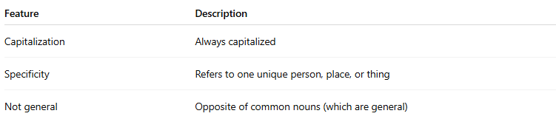
Feature | Description
Capitalization | Always capitalized
Specificity | Refers to one unique person, place, or thing
Not general | Opposite of common nouns (which are general)

🧠 Proper Noun vs. Common Noun:
# Source: AI Source: Provided by: [Data Path: Persons Table -> ID Column: 1, Name_En Column: Motasem Essam] -> From: [Chatgpt (GPT-4-turbo)] on [7/26/2025]
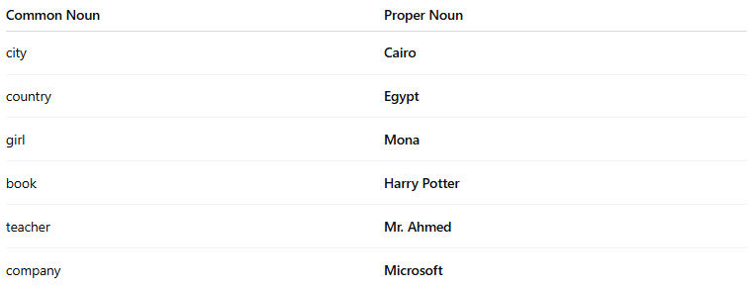
Common Noun | Proper Noun
city | Cairo
country | Egypt
girl | Mona
book | Harry Potter
teacher | Mr. Ahmed
company | Microsoft

📚 Categories of Proper Nouns:
# Source: AI Source: Provided by: [Data Path: Persons Table -> ID Column: 1, Name_En Column: Motasem Essam] -> From: [Chatgpt (GPT-4-turbo)] on [7/26/2025]
- People’s Names
  - Ahmed, Sarah, William Shakespeare
- Geographical Names
  - Africa, Nile River, Mount Everest
- Institutions & Organizations
  - Google, United Nations, Cairo University
- Events & Holidays
  - Ramadan, World War II, Eid al-Fitr
- Brand Names
  - Samsung, Coca-Cola, Nike
- Book & Movie Titles
  - The Lord of the Rings, Quran, Titanic

📝 Example Sentences:
# Source: AI Source: Provided by: [Data Path: Persons Table -> ID Column: 1, Name_En Column: Motasem Essam] -> From: [Chatgpt (GPT-4-turbo)] on [7/26/2025]
- Ali visited London in the summer.
- We read Romeo and Juliet in class.
- She works at Apple Inc.

